Aptify – Azure CB Hosted Deployment

Customer Onboarding Final Steps

---------------------------------------------------------------------------------------

Aptify – Azure CB Hosted Deployment
Summary
This BICEP is an IAC (Infrastructure as Code) deployment that will deploy all resources using “Modules” within the file to call them and deploy them separately. All the Code is formatted to use similar formats and use some base parameters throughout all the code to have a simple to read deployment. Aptify uses Azure DevOps to validate all the code before running using an Enterprise application Azure AD object id for permissions to deploy code.
Azure DevOps Pipeline:
https://dev.azure.com/CBCloudOps-Production/AptifyCloud/_build?view=pipelines
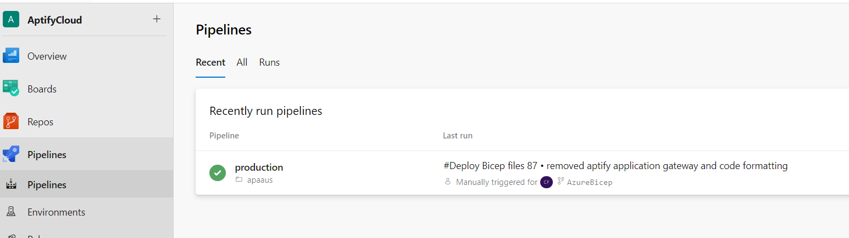
Azure DevOps will deploy the files and resources into the configured subscription

NOTE:
- Do not create SQL Managed Instance if you do not have Server Collation and Database collation details from Requester
- Do not create SQL managed instance if you do not have Region and Timezone in which Database need to create from requester
Pre-deployment Steps:
- Create customer Subscription.
- Login to Azure DevOps and create Service Connection for the newly created Subscription.
  - Refer to below for steps on how to create service connection
    - In Azure DevOps, click on Project Settings>Pipelines>Service connections
    - Click New Service connection button in upper right corner
    - Select Azure Resource Manager radio button, click Next
    - For Authentication method, select Service principal (automatic), click Next.
    - Settings:
      - Select target Azure subscription
      - Leave Resource group blank
      - Service connection name:
        - PROD-Aptify-<acronym>-(<sub ID>)
      - Save
- Set up local environment use this link for further detailsx
  - Azure - Set up local Git Environment.docx
- Add VNet subnet IP range to the excel document “Azure Virtual network list”
  - Azure Virtual CIDR ranges
- Find the deployment folder inside the repository and create "pipelines.yaml" and "parameters.bicepparam" files for the client. Push changes to the repository.
- Create Azure AD customer group objects to pass object ID to BICEP principal ID.
  - Name should be: Aptify-Customers-<acronym>
  - IMPORTANT - Add new group to ‘Aptify Customers’ group
  - Add new group to Azure AD Domain Services group
    - Go to Prod IT Operations Subscription>Domain Services Resource Group>cbcloudprod.com Domain Services>Synchronization
    - Click on Add Groups and add new customer group
- Add new customer group to Enterprise Application MicrosoftAzureActiveAuthn
  - NOTE: In Azure Entra, go to Enterprise Applications>All Applications. Clear filter and search for MicrosoftAzureActiveAuthn. Click on MicrosoftAzureActiveAuthn>Users and groups and add new customer group.
- Add the customer Group ID to the synchronization groups within Microsoft Entra Domain Services to sync the users into the domain
- Create Azure DevOps pipeline
  - In Azure DevOps, navigate to pipeline page for AptifyCloud:
    - https://dev.azure.com/CBCloudOps-Production/AptifyCloud/_build
  - On the ‘All’ tab, create new folder. Name should be lowercase customer acronymn. ‘pat’, for example.
  - Expand the new folder, click on Create a new pipeline here.
    - Select Azure Repos Git
    - Select AptifyCloud repo
    - Select ‘Existing Azure pipeline YAML file’
    - Select working branch
    - Enter path to pipelines.yaml for the environment you will be deploying. Example:
      - Azure/bicepdeployment-cbhosting/pipelines/PAT/production/pipelines.yaml
- Deploy Azure DevOps Pipeline or use Azure CLI command to deploy resources
- Add pipeline application to Aptify Deployment group
- Add SQL admin password in Key Vault aptify-deployment. Use name format “sql-<customername>”
Post-deployment Steps:
- Verify Qualys agent is installed in VM (Only for production)
- (Skip. Automated using Bicep) Enable application insights for Aptify and EBusiness app services
- Configure app services custom domains using aptify.cloud domain initially. “aptify.cloud” dns zone available in the Aptify Prod AWS account
- (Skip. We are using Cloudflare) Setup application gateway. Instructions:Aptify - Azure Application Gateway Configuration.docx
- Grant SQL Managed Instance Read access to Azure Entra ID
- Add SQL Managed Instance admin credentials to LastPass. These values are available in the Key Vault “aptify-deployment” in PROD IT Operation subscription
- (Skip. Automated using Bicep) Run PowerShell runbooks onto SSRS and Session Host session deployments within CloudOps Automation Account. NOTE – This is now automated, but if the VMs are missing requirements, the runbooks below can be executed.
  - SSRS:
    - https://portal.azure.com/#@communitybrandscloud.onmicrosoft.com/resource/subscriptions/f719bf19-2686-4eba-8075-57329a42ea29/resourceGroups/IT-Ops/providers/Microsoft.Automation/automationAccounts/CloudOps/runbooks/aptiffy-ssrs-configuration/overview
  - Smart Client:
    - https://portal.azure.com/#@communitybrandscloud.onmicrosoft.com/resource/subscriptions/f719bf19-2686-4eba-8075-57329a42ea29/resourceGroups/IT-Ops/providers/Microsoft.Automation/automationAccounts/CloudOps/runbooks/aptify-smartclient-configuration/overview
- (Skip. Automated using Bicep) VM access – Virtual machine access for CB employees is controlled through Group Policy in the cbcloudprod.com domain. When a new customer virtual machine is deployed, the servers are automatically added to the AptifyCustomersImplement OU in Active Directory. When a customer goes live, their servers need to be moved to the AptifyCustomersLive OU. To make the change manually, log into prod-mgmt-1 as a domain administrator and open Active Directory Users and Computers. Add smart client, ssrs vms to AptifyCustomersLive OU in Azure AD Domain Services
- Configure Remote Desktop Services on session host VMs. This step is required while we are using Windows Server 2019 for session hosts. We plan on switching to Windows 11 after R&D tests it with Aptify and Azure Virtual Desktop. We are using a shared RDS licensing server in the PROD IT Operations subscription:
Customer Onboarding – Final Steps
- Re-enable Alerts
  - Alerts are created during deployment. They are getting disabled during implementation, so we need to make sure everything is turned back on.
- Configure Pingdom Alerts
- Restrict R&D, Services access
  - Restrict access once customer is live. Customer servers need to be moved to AptifyCustomersLive OU:
  - Add CB employees to customer groups temporarily. Remove when access no longer needed.
- Add virtual Machines to Update management
  - Regional maintenance configurations are configured in PROD-IT-Operations>Monitoring
- Set up maintenance window for SQL Managed instance
  - Usually want to select Fri-Sun 10 PM to 6 AM
- Set up subscription service alerts
  - Go to Service Health page in Azure portal. These should just go to Teams and not pagerduty. Use Aptify-Service-Alerts logic app.
  - Microsoft Azure Health
- Set up security alerts
- Gateway configuration
  - All public access to websites should go through gateway. Need DNS records, SSL cert from customer. User aptify.cloud for initial configuration.
  - Aptify Azure Gateway Configuration
- Configure Remote Desktop Services on session hosts
  - Required while we are using Windows Server 2019. We plan to switch to Windows 11 once R&D tests and approves, and this step will no longer be required.
- Set long term retention policy for the SQL Managed Instance database
    - Prod
      - Keep weeklies for 4 weeks
      - Monthlies for 12 months
      - Keep 1 Yearly for 1 year
    - Lower environments:
      - Keep monthlies for 3 months

